Civil war in Georgia

UNSC Resolution: | 1036
Date of adoption: | 12-Jan-1996
Operative paragraph: | 4
Demand number: | 1036.0411

David Siroky

Wording of demand

achieve substantive progress without further delay towards a comprehensive political settlement (in particular the Abkhaz side) and cooperate with the efforts undertaken by the Secretary-General with the assistance of the Russian Federation as facilitator

List of addressees of the demand

Government of Georgia, Abkhazia

Short-term compliance

Description of the addressee(s)’ conduct

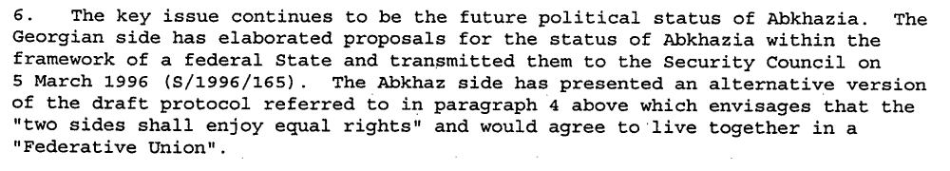

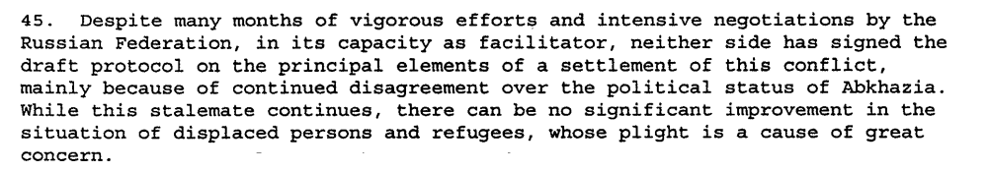

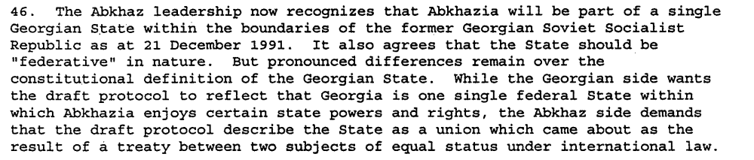

s/1996/284

s/1996/507

Assessment

Short-term compliance
No or marginal compliance (1) | Medium low compliance (2) | Medium high compliance (3) | Full or almost full compliance (4)

Considerations underlying the assessment

Medium-term compliance

Description of the addressee(s)’ conduct

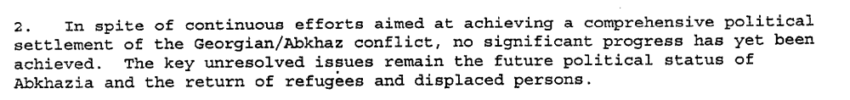s/1996/843

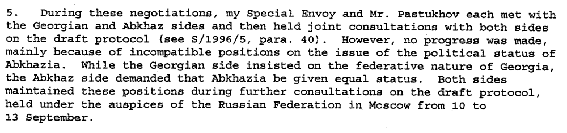s/1996/843

s/1996/843

s/1997/47
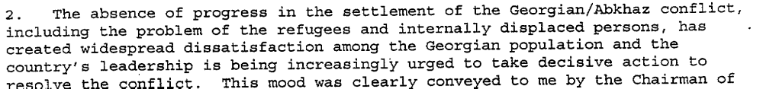
s/1997/340

Assessment

Medium-term compliance
No or marginal compliance (1) | Medium low compliance (2) | Medium high compliance (3) | Full or almost full compliance (4)

Considerations underlying the assessment

Depth of demand

Assessment

Level of depth of demand
Low depth of demand (1) | Medium depth of demand (2) | High depth of demand (3)

Considerations underlying the assessment

Level of confidence about coding decisions
Level of confidence about coding decision
Extremely high | High | Moderate

Comments to IPI (if any)

Civil war in Georgia

UNSC Resolution: | 1036
Date of adoption: | 12-Jan-1996
Operative paragraph: | 5
Demand number: | 1036.0511

David Siroky

Wording of demand

accelerate significantly the process of voluntary return of refugees and displaced persons by accepting a timetable on the basis of that proposed by the Office of the UN High Commissioner for Refugees and guarantee the safety of spontaneous returnees already in the area and regularize their status in accordance with the Quadripartite Agreement

List of addressees of the demand

Abkhazia

Short-term compliance

Description of the addressee(s)’ conduct

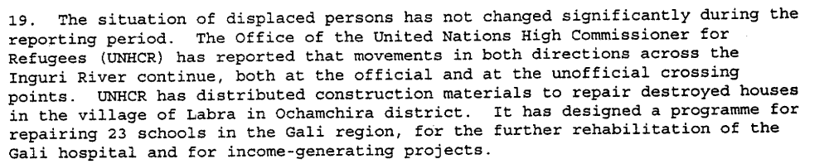

s/1996/284
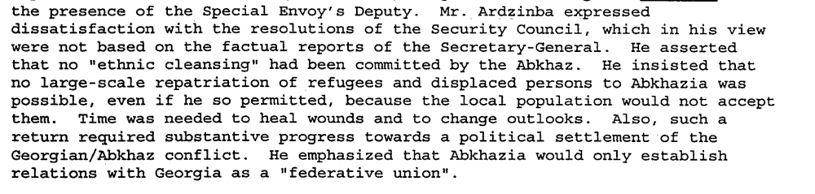
s/1996/507

Assessment

Short-term compliance
No or marginal compliance (1) | Medium low compliance (2) | Medium high compliance (3) | Full or almost full compliance (4)

Considerations underlying the assessment

Medium-term compliance

Description of the addressee(s)’ conduct

s/1997/47

s/1997/47

s/1997/340

Assessment

Medium-term compliance
No or marginal compliance (1) | Medium low compliance (2) | Medium high compliance (3) | Full or almost full compliance (4)

Considerations underlying the assessment

Depth of demand

Assessment

Level of depth of demand
Low depth of demand (1) | Medium depth of demand (2) | High depth of demand (3)

Considerations underlying the assessment

Level of confidence about coding decisions

Level of confidence about coding decision
Extremely high | High | Moderate

Comments to IPI (if any)

Civil war in Georgia

UNSC Resolution: | 1036
Date of adoption: | 12-Jan-1996
Operative paragraph: | 6
Demand number: | 1036.0611

David Siroky

Wording of demand
in the context of op. 5 of current resolution to promote, as a first step, the return of refugees and displaced persons to the Gali region, in safety and dignity

List of addressees of the demand

Abkhazia

Short-term compliance

Description of the addressee(s)’ conduct

s/1996/284

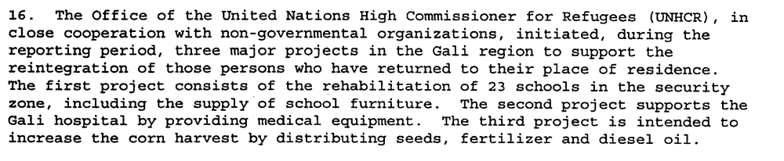
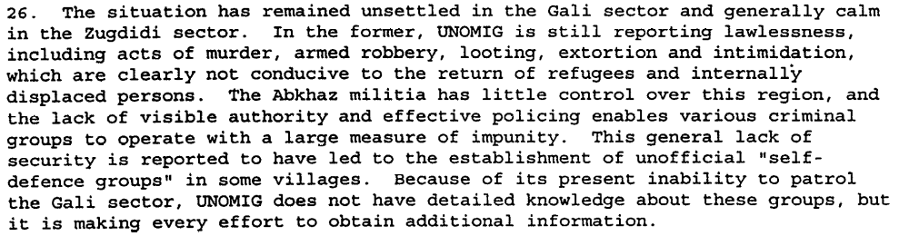

s/1996/507

Assessment

Short-term compliance
No or marginal compliance (1) | Medium low compliance (2) | Medium high compliance (3) | Full or almost full compliance (4)

Considerations underlying the assessment

Medium-term compliance

Description of the addressee(s)’ conduct

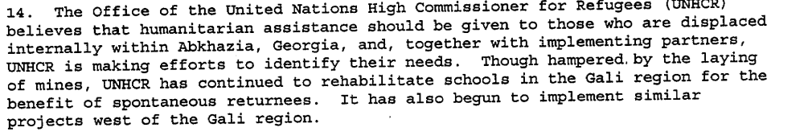s/1996/843

s/1997/47

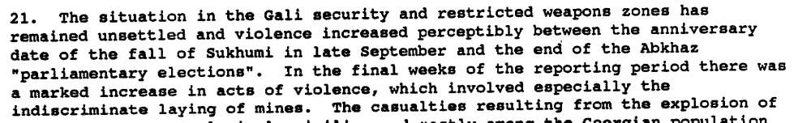

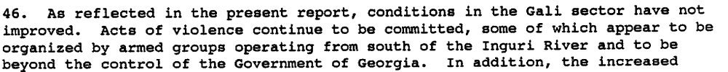
s/1997/47

Assessment

Medium-term compliance
No or marginal compliance (1) | Medium low compliance (2) | Medium high compliance (3) | Full or almost full compliance (4)

Considerations underlying the assessment

Depth of demand

Assessment

Level of depth of demand
Low depth of demand (1) | Medium depth of demand (2) | High depth of demand (3)

Considerations underlying the assessment

Level of confidence about coding decisions

Level of confidence about coding decision
Extremely high | High | Moderate

Comments to IPI (if any)

Civil war in Georgia

UNSC Resolution: | 1036
Date of adoption: | 12-Jan-1996
Operative paragraph: | 7
Demand number: | 1036.0711

David Siroky

Wording of demand

ensure the safety of all persons in areas under its control

List of addressees of the demand

Abkhazia

Short-term compliance

Description of the addressee(s)’ conduct

s/1995/507

Assessment

Short-term compliance
No or marginal compliance (1) | Medium low compliance (2) | Medium high compliance (3) | Full or almost full compliance (4)

Considerations underlying the assessment

Medium-term compliance

Description of the addressee(s)’ conduct

s/1997/47

Assessment

Medium-term compliance
No or marginal compliance (1) | Medium low compliance (2) | Medium high compliance (3) | Full or almost full compliance (4)

Considerations underlying the assessment

Depth of demand

Assessment

Level of depth of demand
Low depth of demand (1) | Medium depth of demand (2) | High depth of demand (3)

Considerations underlying the assessment

Level of confidence about coding decisions

Level of confidence about coding decision
Extremely high | High | Moderate

Comments to IPI (if any)

Civil war in Georgia

UNSC Resolution: | 1036
Date of adoption: | 12-Jan-1996
Operative paragraph: | 8
Demand number: | 1036.0811

David Siroky

Wording of demand

improve cooperation with UNOMIG and the CIS peace-keeping force in order to provide a secure environment for the return of refugees and displaced

List of addressees of the demand

Government of Georgia, Abkhazia

Short-term compliance

Description of the addressee(s)’ conduct

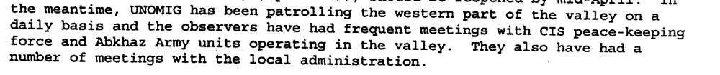s/1996/284

s/1996/284

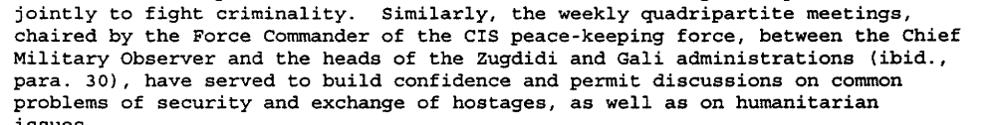

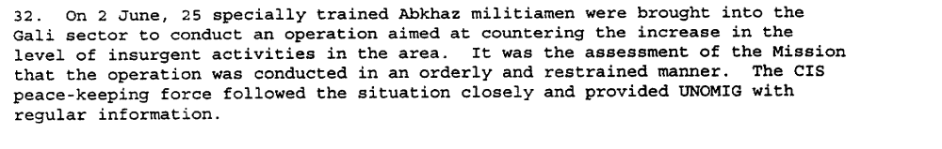

s/1996/507

Assessment

Short-term compliance
No or marginal compliance (1) | Medium low compliance (2) | Medium high compliance (3) | Full or almost full compliance (4)

Considerations underlying the assessment

Medium-term compliance

Description of the addressee(s)’ conduct

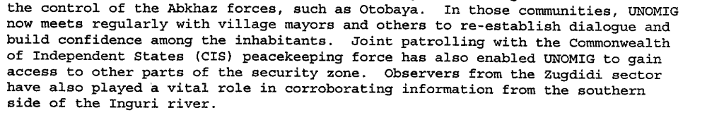s/1996/843

s/1996/843

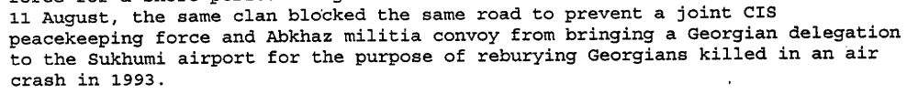

s/1996/843

s/1997/47

s/1997/47

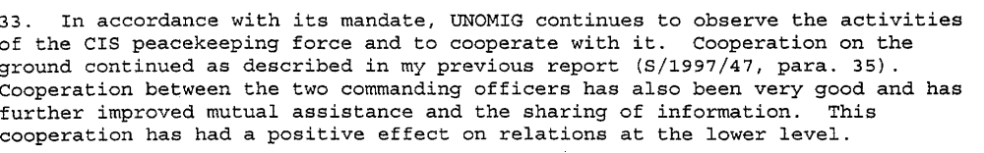s/1997/340

Assessment

Medium-term compliance
No or marginal compliance (1) | Medium low compliance (2) | Medium high compliance (3) | Full or almost full compliance (4)

Considerations underlying the assessment

Depth of demand

Assessment

Level of depth of demand
Low depth of demand (1) | Medium depth of demand (2) | High depth of demand (3)

Considerations underlying the assessment

Level of confidence about coding decisions

Level of confidence about coding decision
Extremely high | High | Moderate

Comments to IPI (if any)

Civil war in Georgia

UNSC Resolution: | 1036
Date of adoption: | 12-Jan-1996
Operative paragraph: | 10
Demand number: | 1036.1011

David Siroky

Wording of demand

cooperate fully with efforts to elaborate a concrete programme for the protection and promotion of human rights in Abkhazia, Georgia, as described in the Secretary-General's report of 2 January 1996 (S/1996/5)

List of addressees of the demand

Abkhazia

Short-term compliance

Description of the addressee(s)’ conduct

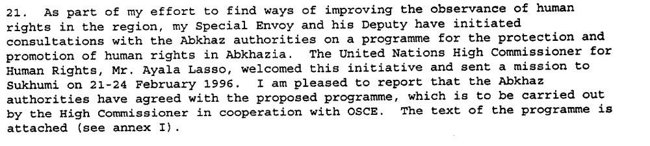s/1996/284

Assessment

Short-term compliance
No or marginal compliance (1) | Medium low compliance (2) | Medium high compliance (3) | Full or almost full compliance (4)

Considerations underlying the assessment

Medium-term compliance

Description of the addressee(s)’ conduct

s/1997/340

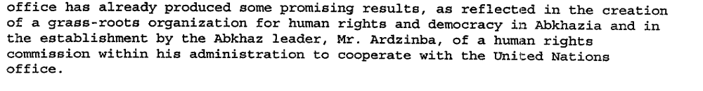
s/1997/340

Assessment

Medium-term compliance
No or marginal compliance (1) | Medium low compliance (2) | Medium high compliance (3) | Full or almost full compliance (4)

Considerations underlying the assessment

Depth of demand

Assessment

Level of depth of demand
Low depth of demand (1) | Medium depth of demand (2) | High depth of demand (3)

Considerations underlying the assessment

Level of confidence about coding decisions

Level of confidence about coding decision
Extremely high | High | Moderate

Comments to IPI (if any)

